CLOUD COMPOUTING

ASSIGNMENT 1

VINOD KUMAR 2280165

LAB 1 :
Task1:
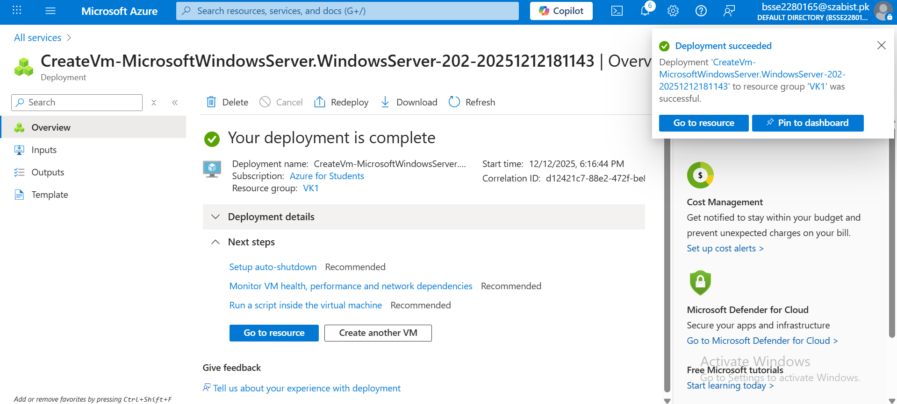

Task 2:
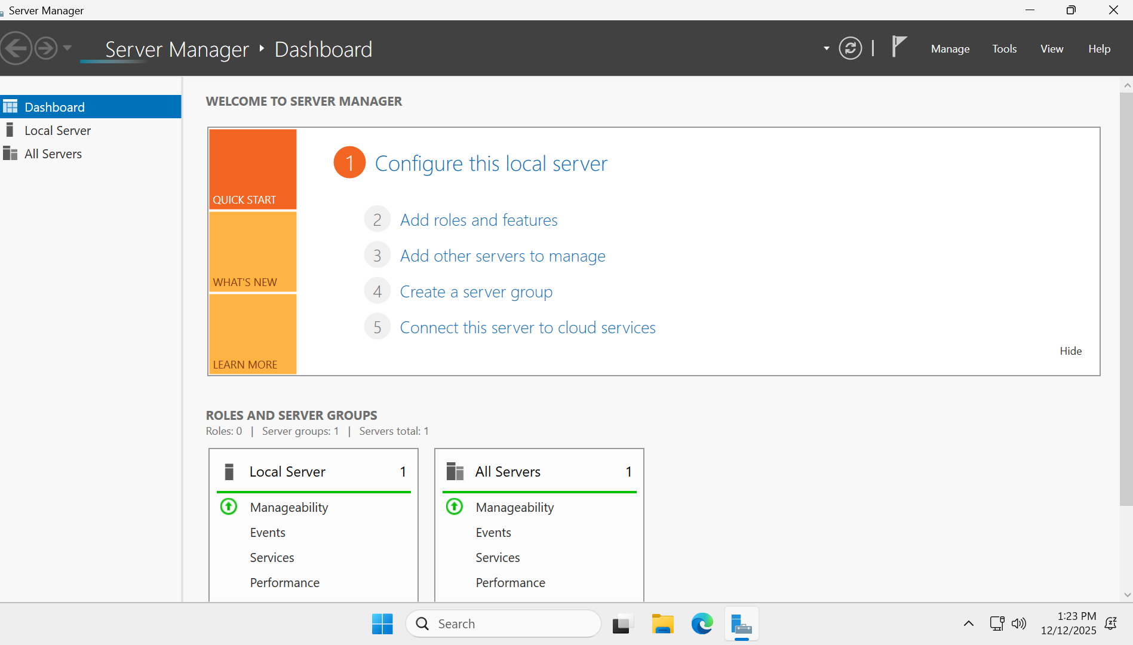
TASK 3:
